

#### HUMAN BIOLOGICAL SCIENCES STAGE 2

## **CIRCULATORY SYSTEM**

**EXTENDED RESPONSE**

Name: ___________________________________

**Circulatory System Extended Response**

1. The diagram below schematically represents the blood flow into and out of the heart.

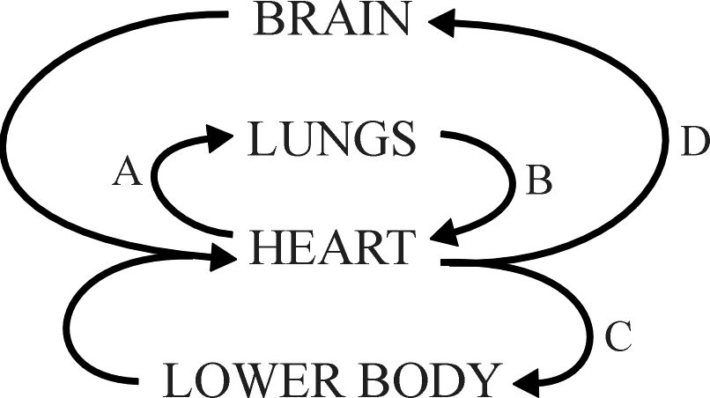

1. Blood taken from which part of the circulatory system (A, B, C of D) would have the highest concentration of oxygen. [1]

**B**

1. Name blood vessel A. [1] **Pulmonary artery**
2. To which chamber of the heart is blood vessel B connected? [1]

**Left Atrium**

1. Name the major blood vessel from which C and D branch. [1]

**Aorta**

1. Veins have a much lower blood pressure than arteries. Discuss the mechanisms that enable veins to return blood to the heart despite this relatively low blood pressure. [2]

**Valves prevent back flow of blood [1]**

**Skeletal muscles squeeze veins pushing blood along [1]**

1. Electrocardiograms can be used to measure heart rate and analyse the functioning of the heart.
   1. There are three main parts to an ECG – P-wave, QRS complex and T-wave. Label these parts on the ECG below. [1]

T-wave

P-wave

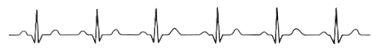

QRS complex

* 1. What is happening in the heart when each of these waves is formed? [3]

**P-wave = atria contract (depolarise)**

***QRS complex = ventricles contract (depolarise)***

***T-wave = ventricles relax (repolarise)***

* 1. Why is the P wave so much smaller than the QRS complex? [1]

**The atria have less muscle mass than the ventricles**

* 1. If the ECG trace above was taken over a period of 5 seconds, what was the person’s heart rate? [1]

**60 bpm**

1. Blood pressure in arteries is measured using an instrument called a sphygmomanometer. Explain in detail how you would use this instrument to measure blood pressure. Your answer should include information on the meaning of systolic and diastolic pressure. [5]

**Systolic – highest pressure caused by contraction of ventricles [1]**

**Diastolic – lowest pressure occurs the heart is relaxed [1]**

**Place cuff around arm / inflate until blood is cut off to forearm / place**

**stethoscope over brachial artery [1]**

**Slowly deflate cuff until sound of pulse is heard = systolic pressure [1]**

**Deflate further until blood is heard flowing continuously = diastolic pressure [1]**

1. Consider the following graph:

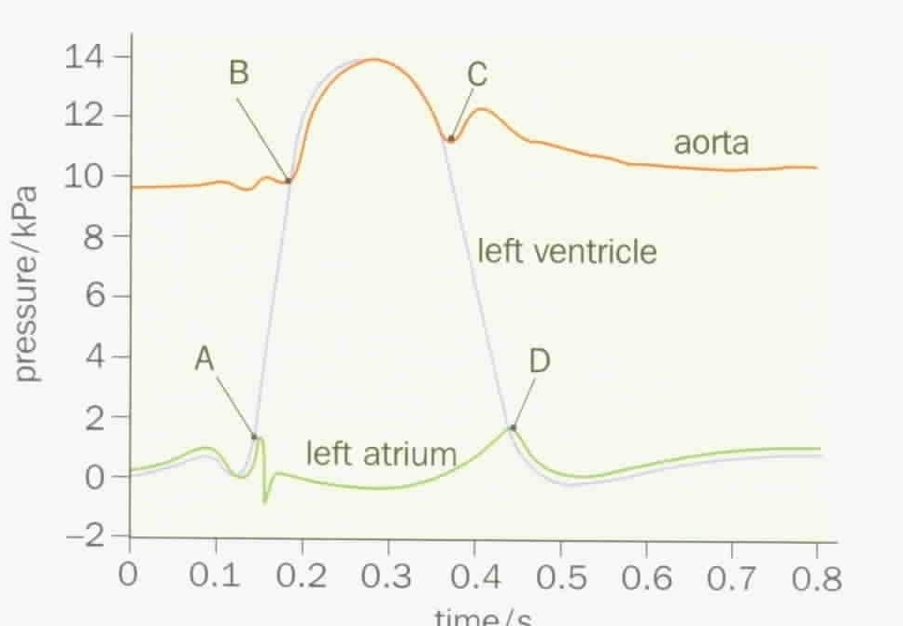

* 1. At point A the pressure in the left ventricle starts to exceed the pressure of the left atrium. What effect would this have on the left atrioventricular valve? [1]

**Closes**

* 1. At point B the pressure of the left ventricle starts to exceed the pressure of the aorta. What effect would this have on the aortic valve? [1]

**Open**

5. Below is an image of a blood smear taken through a light microscope.

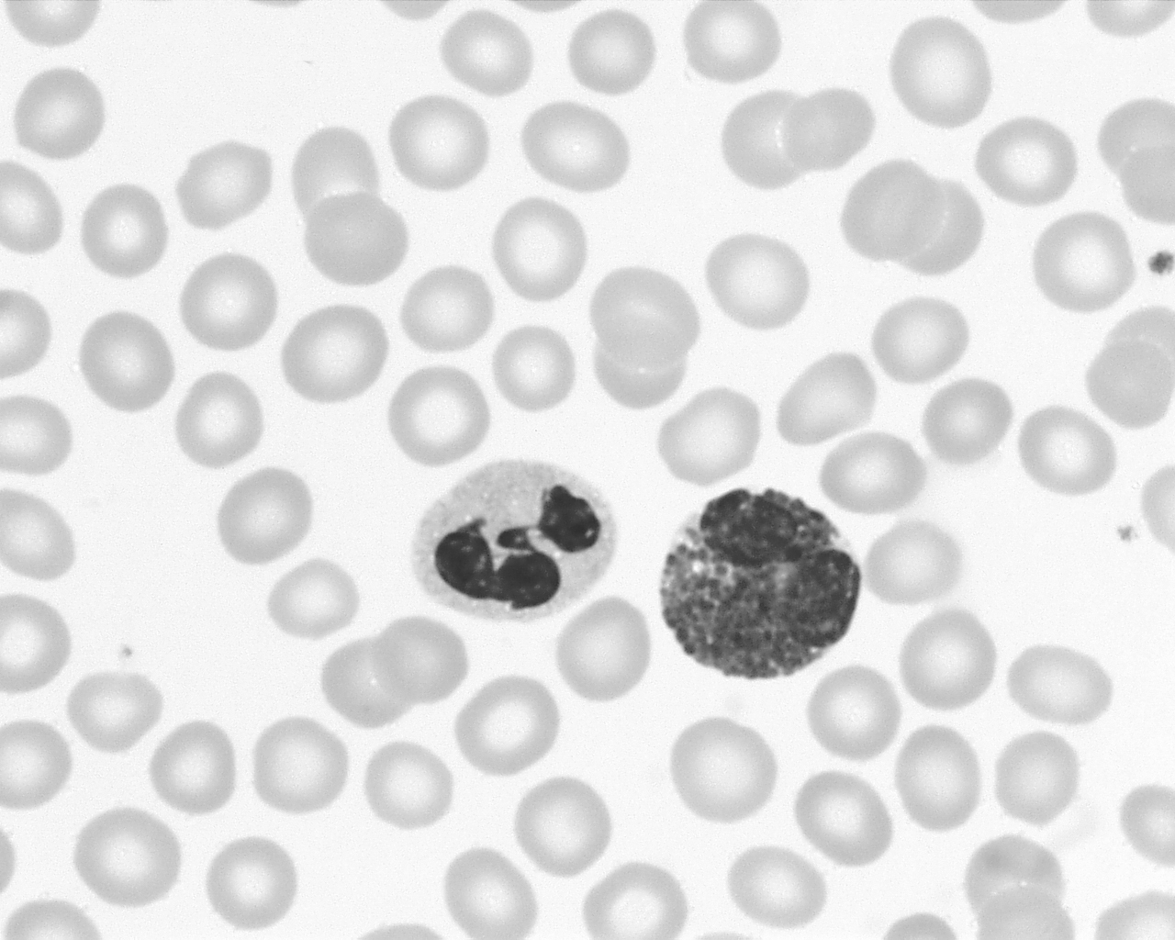

The cell identified by the arrow is a white blood cell.

1. Give two structural features of this cell that distinguish it from the red blood cells. [2]

**Larger / Nucleus present [1 mark each]**

1. Platelets are not easily identified in this image. Describe the function of platelets? [1]

**Help blood to clot**

**END of ASSESSMENT**